Musings on Pooh Bear

I have always felt that the writings of A A Milne were wasted on the young (although both my children loved his poetry and the Christopher Robin stories).

The true philosophy of his work only becomes apparent as we age. Consider the pastime playing Pooh Sticks, which is a seemingly mindless game for a lazy summer day. If you are unfamiliar with this story, you need to find yourself a convenient river (preferably one as lazy as your summer day) with a bridge. Then you gather old twigs and, looking up stream, hang over the side of the bridge and drop the sticks into the river and watch them slowly disappear under the bridge.

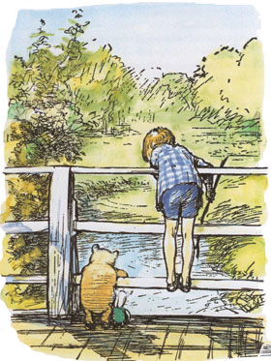

If you are playing with a friend, then the child in you will run to the other side of the bridge to see whose stick came through first. We are so competitive! And then of course you run back and play the next round.

However, if in some way you have grown up (lots of people have grown up – it’s a biological thing, as against becoming an adult which is a choice) – you might just throw your sticks into the river and watch them disappear.

If you were to imagine that every stick was one of troubles and fears, as you drop it, you can imagine it disappearing from your life as it slow slips under the bridge. You can just let your troubles flow away from you. The river doesn’t care about your troubles and it is very happy to carry them away.

A word of warning – keep a tight rein on ‘your child’ and don’t let it go running to watch your troubles surfacing on the other side, as this negates the therapeutic reaction of playing Pooh Sticks on a warm summer day.

